

INFO 2315: Data Structure (S11)

Project 1

Ramandeep Singh  
100394782



October 26, 2022

**Theme**  
 Designed a game in which there are three entities: Robot (Player), Dragon (Enemy) and Zombie (Enemy). The robot can shoot bullets to kill the enemies. The dragon can also shoot fire balls towards player to kill the robot. The robot can fly, as well as move left and right.

**Diagram**

Dragon uses Firebullet

Robot uses bullet

FireBullet

Bullet

Zombie

Dragon

Robot

Enemy

Player

Character

<<interface>>  
CharacterUpdate

**Functioning**  
- Robot can move left and right using the ‘A’ and ‘D’ key respectively.  
- Robot can fly by holding the ‘Space” key  
- Robot can shoot bullets using the Mouse Click.  
- Killing a Zombie will give 10 points.  
- Killing a Dragon will give 50 points.  
- Enemy can spawn from either left or right side of the screen.  
- Dragons shoot fireball towards the player.  
- Touching the fireball will kill the player.  
- Touching any enemy will kill the player.

**Screenshots**  
  
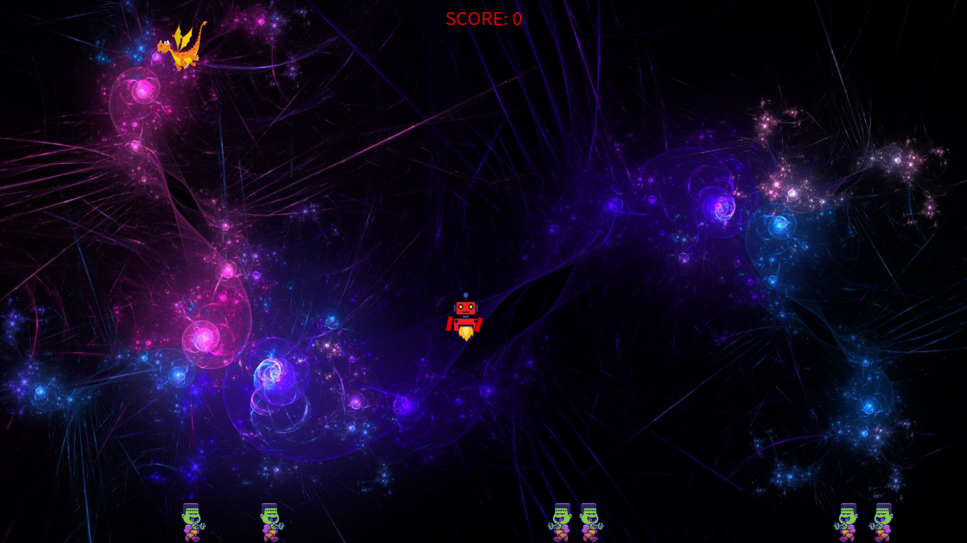

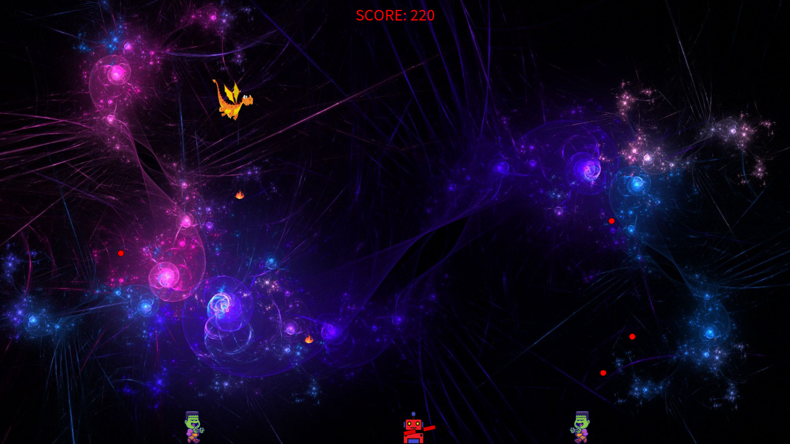  
  
  
  
  
  
  
Output displaying the enemy’s co-ordinates and time when it gets killed by the player.

**Important Formulas**- The formula given below calculates the distance between the Player (Robot) and Enemy (Dragon or Zombie) and check if they collide with each other. If the distance gets less than their respective width, the Player gets killed and the game is over.  
  
- The formula given below move, display and check for the collision of the firebullets with the player. If the bullets overlap with the player image, the player (Robot) gets killed and the game is over. **Graphical user interface, text, application
**

**References**  
- *Robot image:*   
<https://www.google.com/url?sa=i&url=https%3A%2F%2Fuxwing.com%2Frobot-line-icon%2F&psig=AOvVaw2R5VvizMTVZ3SRSwSeMus&ust=1666857122831000&source=images&cd=vfe&ved=0CA0QjRxqFwoTCNib9ea0_foCFQAAAAAdAAAAABAF>   
- *Dragon image:*  
<https://www.google.com/search?q=flysing+dragon+icon&tbm=isch&ved=2ahUKEwith6D-tP36AhVGLTQIHdHNAiYQ2-cCegQIABAA&oq=flysing+dragon+icon&gs_lcp=CgNpbWcQAzoECCMQJzoECAAQQzoFCAAQgAQ6BggAEAcQHlDBBliZE2CXFGgBcAB4AIABSYgBsgSSAQIxMJgBAKABAaoBC2d3cy13aXotaW1nwAEB&sclient=img&ei=U-dYY-2RN8ba0PEP0ZuLsAI&bih=731&biw=1536&client=firefox-b-d>  
- *Zombie image:*  
<https://www.google.com/search?q=zombie+moving+right+icon&tbm=isch&ved=2ahUKEwjHjeaitf36AhWnHTQIHZiPADkQ2-cCegQIABAA&oq=zombie+moving+right+icon&gs_lcp=CgNpbWcQAzoECCMQJ1CiCViPCmDWC2gAcAB4AIABRogB8QGSAQE0mAEAoAEBqgELZ3dzLXdpei1pbWfAAQE&sclient=img&ei=oOdYY8e9Iae70PEPmJ-CyAM&bih=731&biw=1536&client=firefox-b-d>